CPE301 – SPRING 2019

Design Assignment 1

Student Name: John Duriman

Student #: 5002373995

Student Email: duriman@unlv.nevada.edu

Primary Github address:

Directory:

1. **COMPONENTS LIST AND CONNECTION BLOCK DIAGRAM w/ PINS**

Only Atmel Studio was used for this assignment

1. **INITIAL/MODIFIED/DEVELOPED CODE OF TASK 1/A**

None

1. 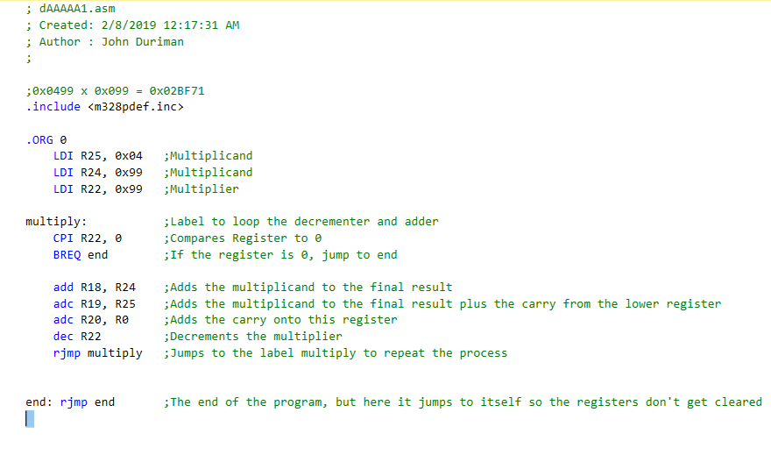**DEVELOPED MODIFIED CODE OF TASK 2/A from TASK 1/A**
2. **SCHEMATICS**

None

1. **SCREENSHOTS OF EACH TASK OUTPUT (ATMEL STUDIO OUTPUT)**

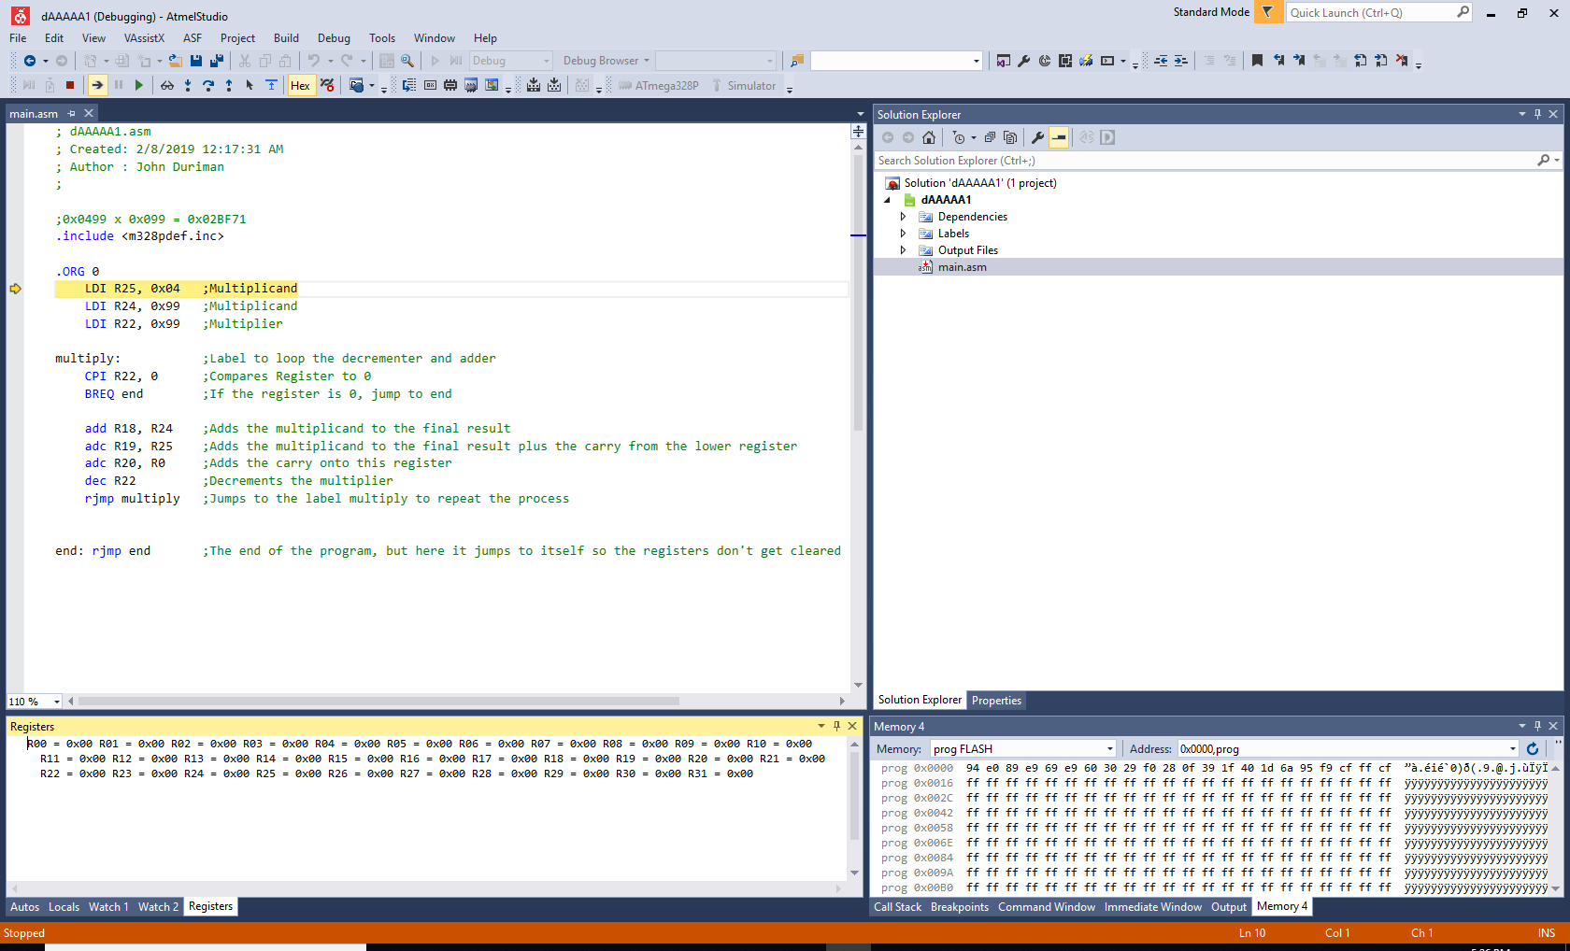

Figure 1 shows the beginning of debugging when all the registers are still empty (0x00)

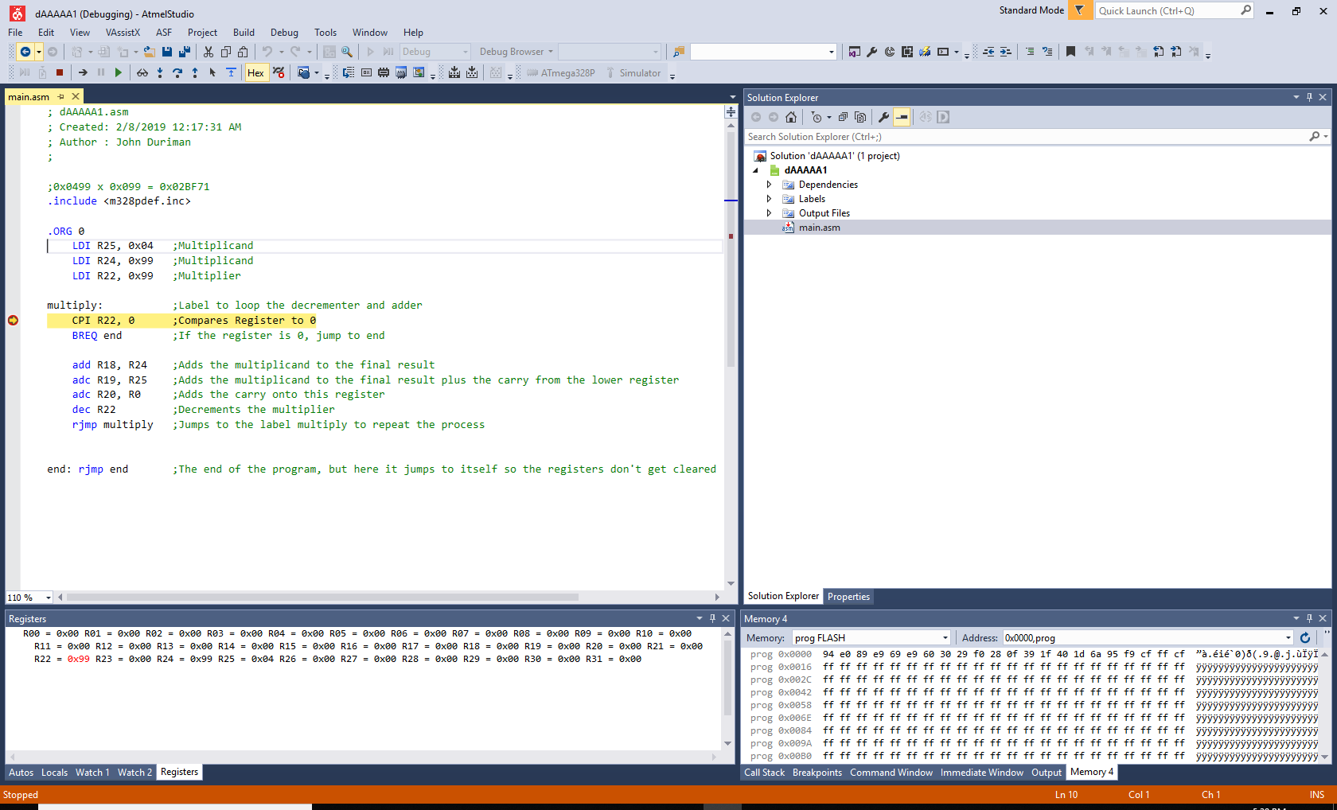

Figure 2 shows a breakpoint right after the label "multiply" and has loaded values R25 = 0x04, R24 = 0x99, and R22 = 0x99.

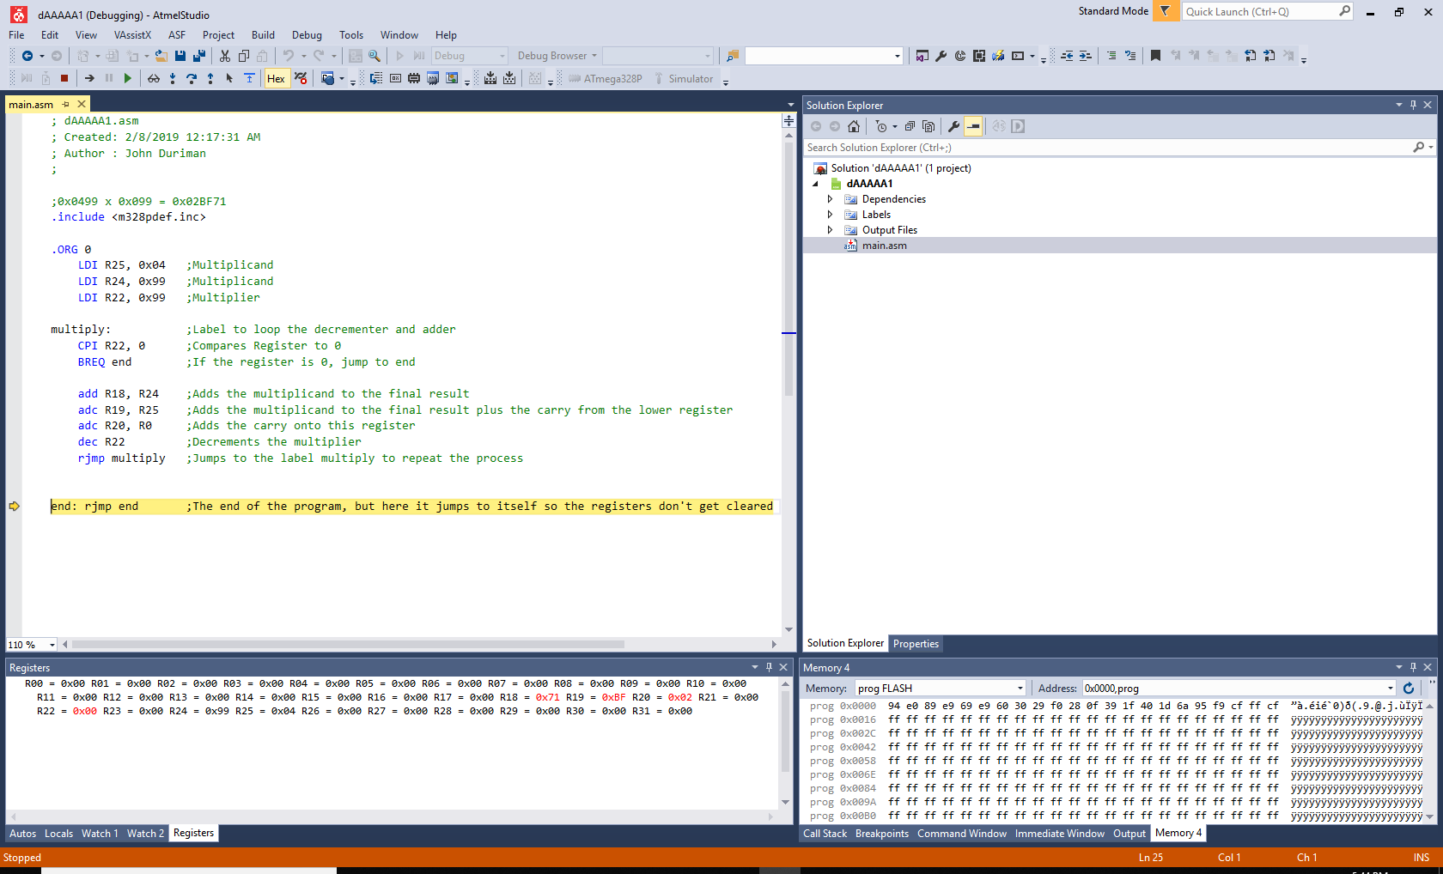

Figure 3 shows that the debugger has ran through all the code and is now looping through the "end" label. Registers R20, R19, and R18 are showing the appropriate values when the multiplicand and the multiplier is multiplied together. The result is 0x02BF71.

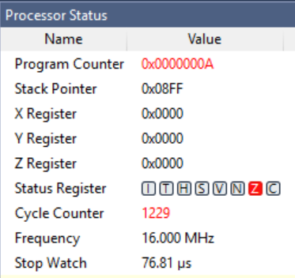

Figure 4 At 16 MHz, it took 76.81 microseconds to execute the code

1. **SCREENSHOT OF EACH DEMO (BOARD SETUP)**

None

1. **VIDEO LINKS OF EACH DEMO**

None

1. **GITHUB LINK OF THIS DA**

https://github.com/johnduriman/pirahnaplant.git

**Student Academic Misconduct Policy**

<http://studentconduct.unlv.edu/misconduct/policy.html>

“This assignment submission is my own, original work”.

NAME OF THE STUDENT